**PL/SQL Exercises**

1.Creating CUSTOMERS Table

CREATE TABLE CUSTOMERS (  
 CustID NUMBER PRIMARY KEY,  
 FullName VARCHAR2(100),  
 CustAge NUMBER,  
 AccountBalance NUMBER(12, 2),  
 VIPStatus VARCHAR2(10) DEFAULT 'NO'  
);

Output:

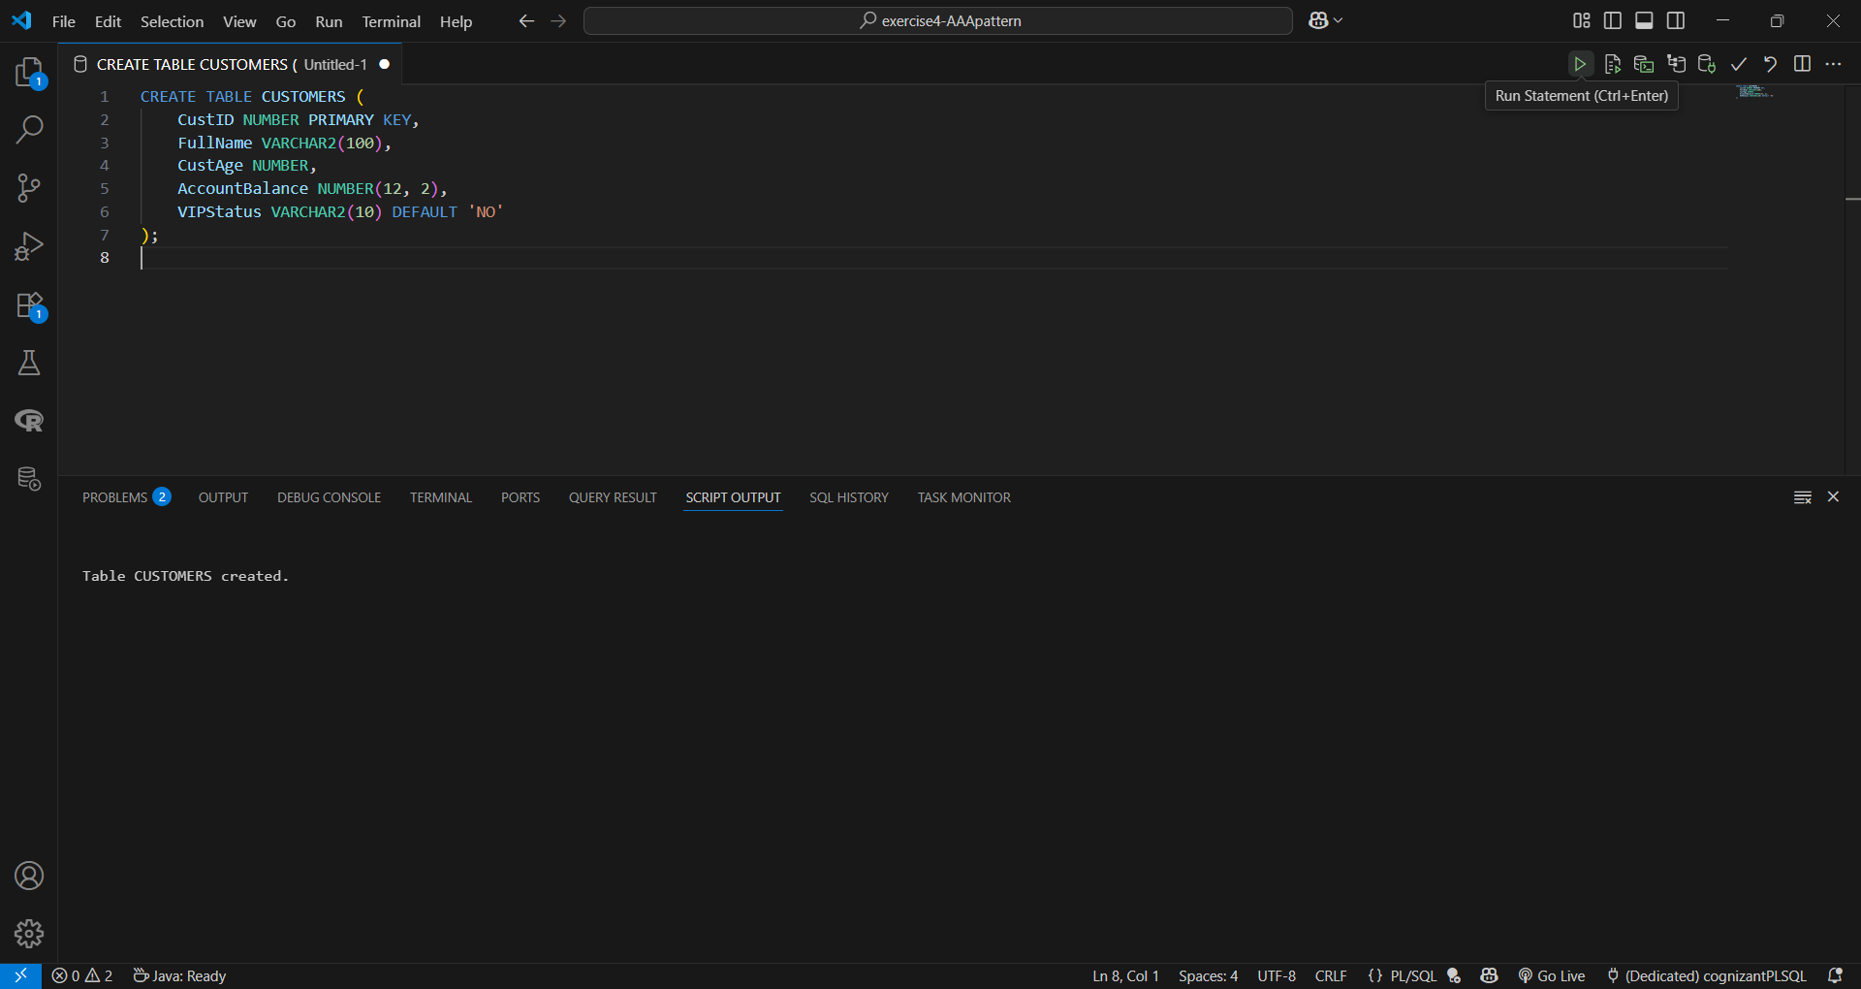.

2.Creating LOANS Table

CREATE TABLE LOANS (  
 LoanNumber NUMBER PRIMARY KEY,  
 CustID NUMBER,  
 Amount NUMBER(12, 2),  
 RateOfInterest NUMBER(5, 2),  
 RepaymentDate DATE,  
 CONSTRAINT fk_cust FOREIGN KEY (CustID) REFERENCES CUSTOMERS(CustID)  
);

Output:

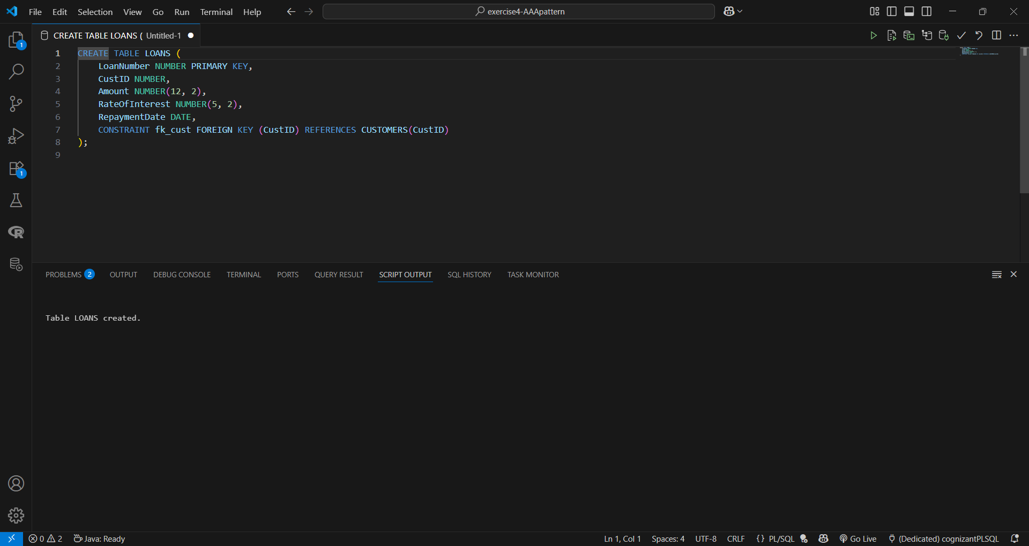

3.Inserting Data into CUSTOMERS

INSERT INTO CUSTOMERS (CustID, FullName, CustAge, AccountBalance) VALUES (1, 'Ravi', 67, 11000.00);  
INSERT INTO CUSTOMERS (CustID, FullName, CustAge, AccountBalance) VALUES (2, 'Teja', 50, 8500.00);  
INSERT INTO CUSTOMERS (CustID, FullName, CustAge, AccountBalance) VALUES (3, 'Vikas', 72, 16000.00);  
INSERT INTO CUSTOMERS (CustID, FullName, CustAge, AccountBalance) VALUES (4, 'Manoj', 43, 9500.00);  
INSERT INTO CUSTOMERS (CustID, FullName, CustAge, AccountBalance) VALUES (5, 'Swathi', 61, 11200.00);

Output:

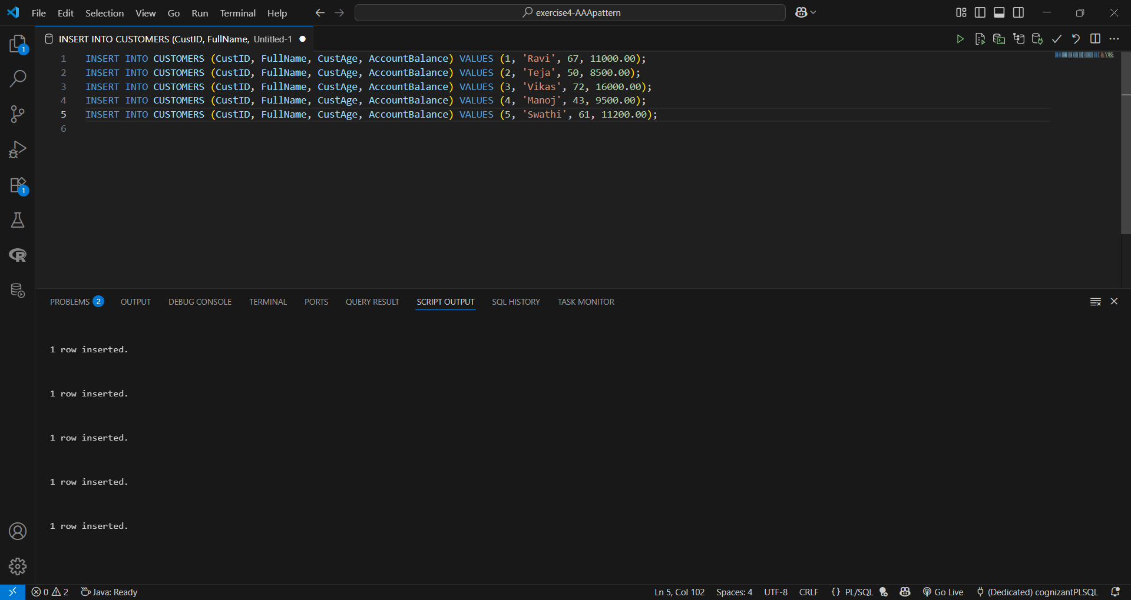

4.Inserting Data into LOANS

INSERT INTO LOANS VALUES (201, 1, 45000.00, 9.0, TO_DATE('2025-07-15', 'YYYY-MM-DD'));  
INSERT INTO LOANS VALUES (202, 2, 32000.00, 10.0, TO_DATE('2025-08-20', 'YYYY-MM-DD'));  
INSERT INTO LOANS VALUES (203, 3, 48000.00, 8.0, TO_DATE('2025-07-10', 'YYYY-MM-DD'));  
INSERT INTO LOANS VALUES (204, 4, 25000.00, 11.0, TO_DATE('2025-07-18', 'YYYY-MM-DD'));  
INSERT INTO LOANS VALUES (205, 5, 42000.00, 9.5, TO_DATE('2025-06-30', 'YYYY-MM-DD'));

Output:

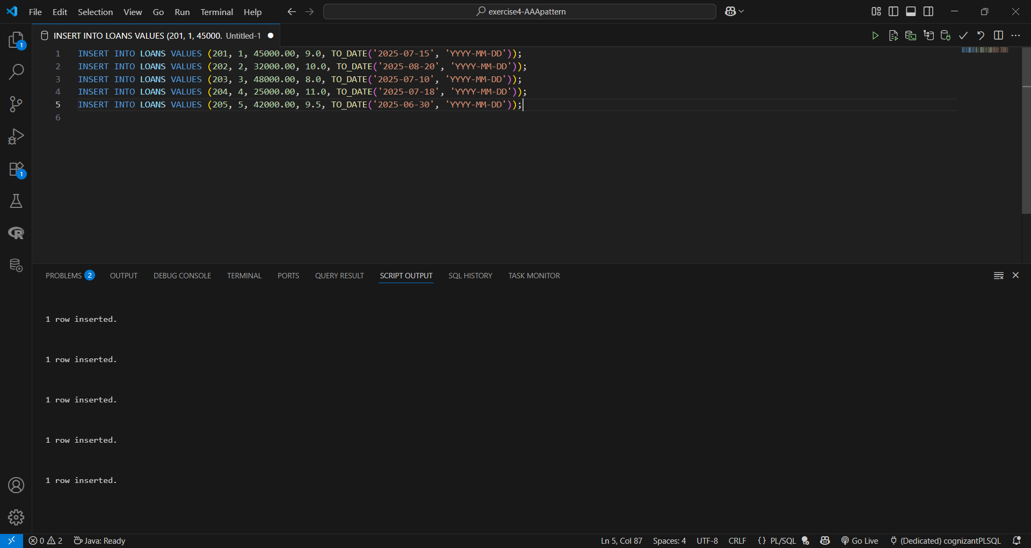

Scenario 1 - Discount for Age > 60

DECLARE   
 custRec CUSTOMERS%ROWTYPE;  
BEGIN   
 FOR custRec IN (SELECT * FROM CUSTOMERS WHERE CustAge > 60) LOOP  
 UPDATE LOANS   
 SET RateOfInterest = RateOfInterest - 1   
 WHERE CustID = custRec.CustID;  
 END LOOP;  
END;  
/

Output:

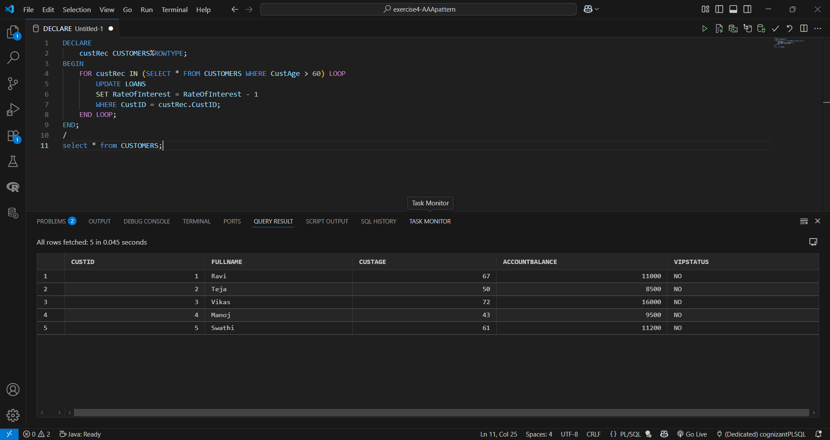

Scenario 2 - VIP Status Based on Balance

DECLARE  
 vipRec CUSTOMERS%ROWTYPE;  
BEGIN  
 FOR vipRec IN (SELECT * FROM CUSTOMERS WHERE AccountBalance > 10000) LOOP  
 UPDATE CUSTOMERS   
 SET VIPStatus = 'YES'   
 WHERE CustID = vipRec.CustID;  
 END LOOP;  
END;  
/

Output:

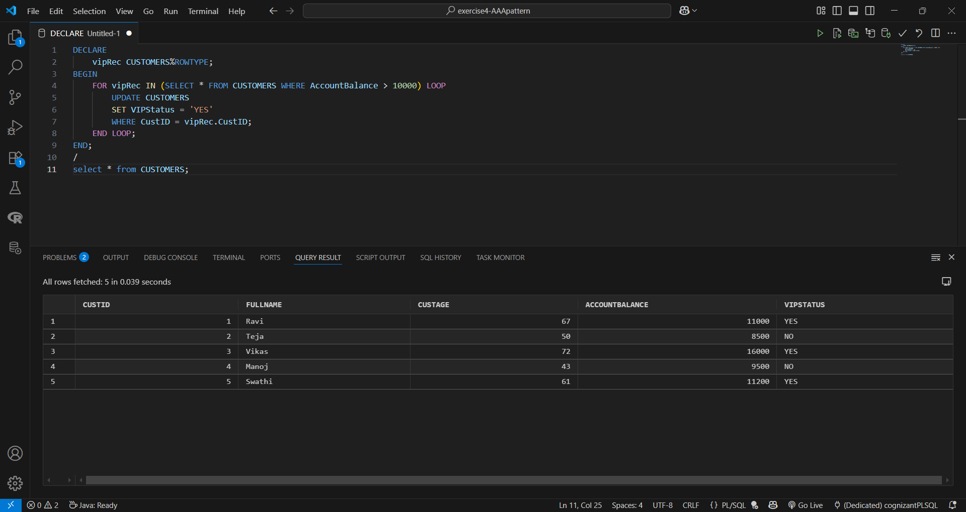

Scenario 3 - Loan Due Reminder

SET SERVEROUTPUT ON;  
DECLARE   
 loanRec LOANS%ROWTYPE;  
 custName VARCHAR2(100);  
BEGIN   
 FOR loanRec IN (SELECT * FROM LOANS WHERE RepaymentDate BETWEEN SYSDATE AND SYSDATE + 30) LOOP  
 SELECT FullName INTO custName FROM CUSTOMERS WHERE CustID = loanRec.CustID;  
 DBMS_OUTPUT.PUT_LINE('Hello ' || custName || ', your loan repayment is due on ' || TO_CHAR(loanRec.RepaymentDate, 'DD-MON-YYYY'));  
 END LOOP;  
END;  
/

Output:

